EDA (E xploratory
Data Analysis)

WEEK - 2

REPORT

SUBMITTED BY:

- SAHANAA SREE
E25DA045

1 . Problem Statement :
To analyze the Superstore sales dataset using Power BI by creating a proper data model, establishing relationships between tables, and developing interactive visualizations to identify sales and customer trends.

Objective :
Create a structured data model using dimension and fact tables.
Establish relationships between Customer, Product, Date, Region, and Sales tables.
Create suitable Power BI visualizations for data analysis.
Analyze sales, customers, products, regions, and monthly trends.
Present the findings through an interactive dashboard.

Tasks and Deliverables :

· Import the Superstore dataset into PowerBI

· Create and organize the following tables :

• Dim_Customer – Customer ID, Customer Name, Segment
• Dim_Date – Date, Day, Month Name, Year, Order Date
• Dim_Product – Product ID, Product Name, Category, Sub-Category
• Dim_Region – City, State/Province, Country/Region
• Sales/Fact Table – Sales transactions and related measures

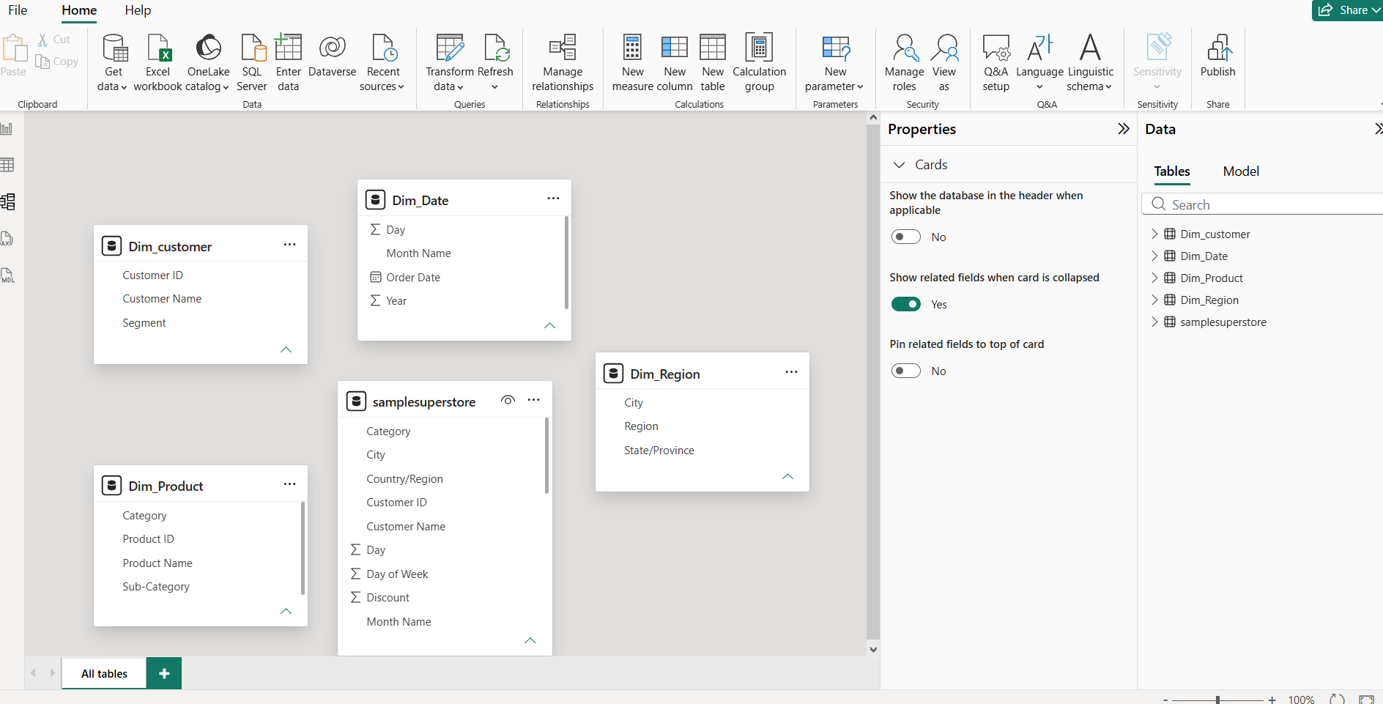

· Establish appropriate relationships between the dimension and fact tables.

· Create calculated measures such as:

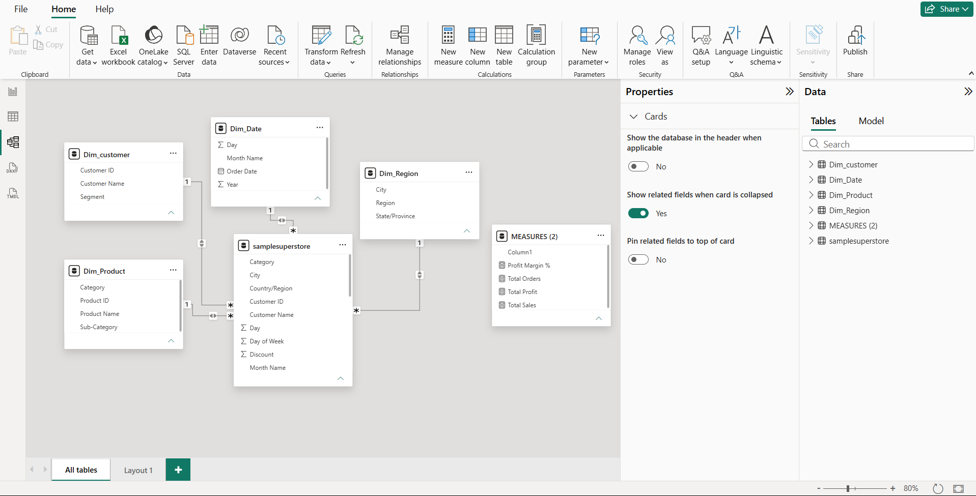

Create visualizations including:
- Column Chart: Sales by Month
- Pie/Donut Chart: Sales distribution by Month
- Stacked Column Chart: Product/Customer count by City or Month
- Line/Area Chart: Monthly sales trend
- Bar Chart: Sales by Product

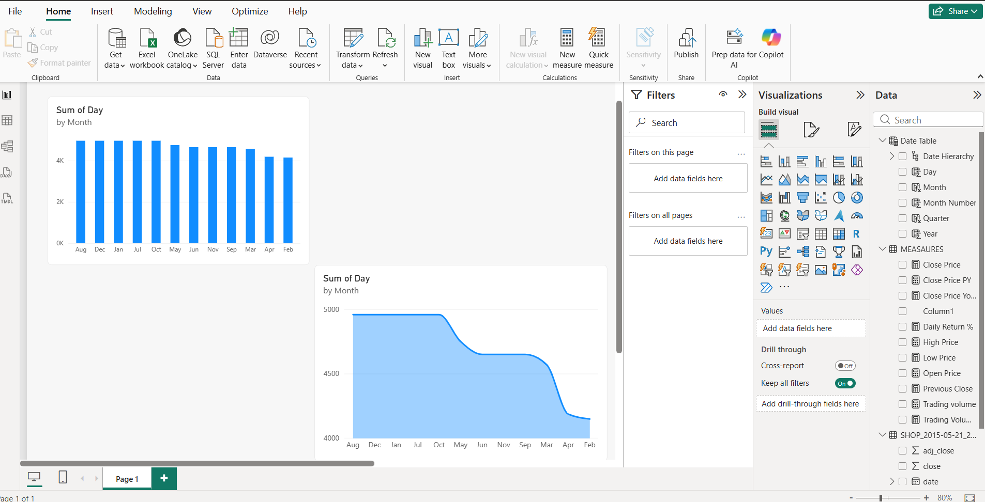

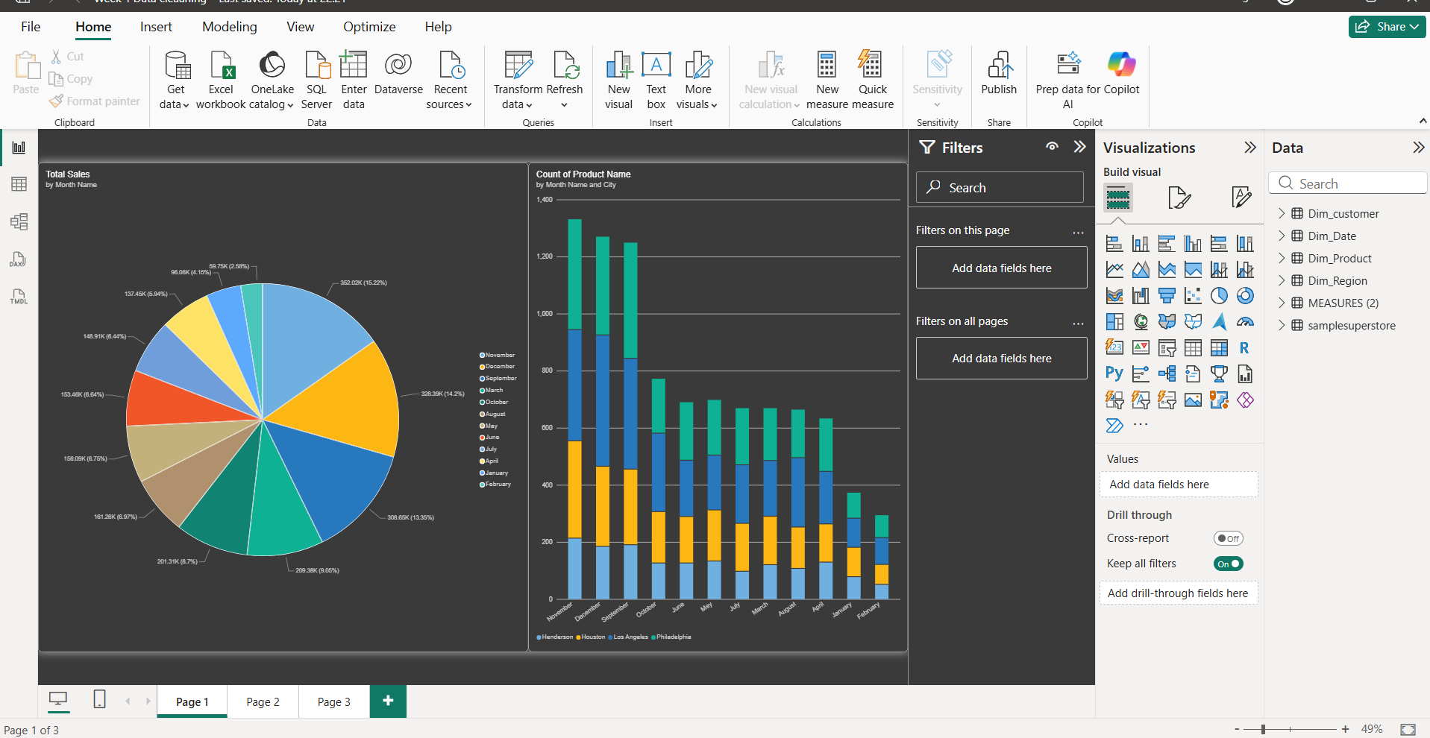

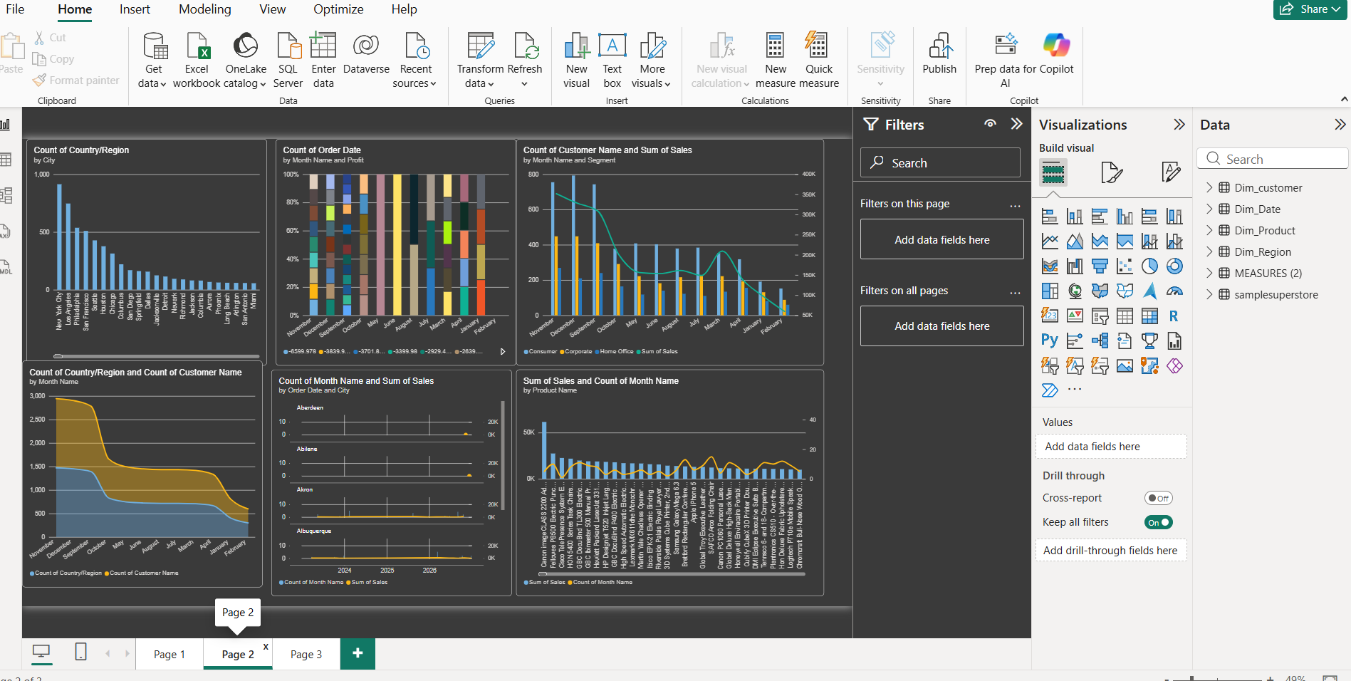

CONCLUSION :

The Week 2 Power BI task successfully demonstrates data modeling, table relationships, calculated measures, and visualization techniques. The dashboard provides a clear view of monthly sales, customers, products, and regional performance, helping users understand business trends and make data-driven decisions.

